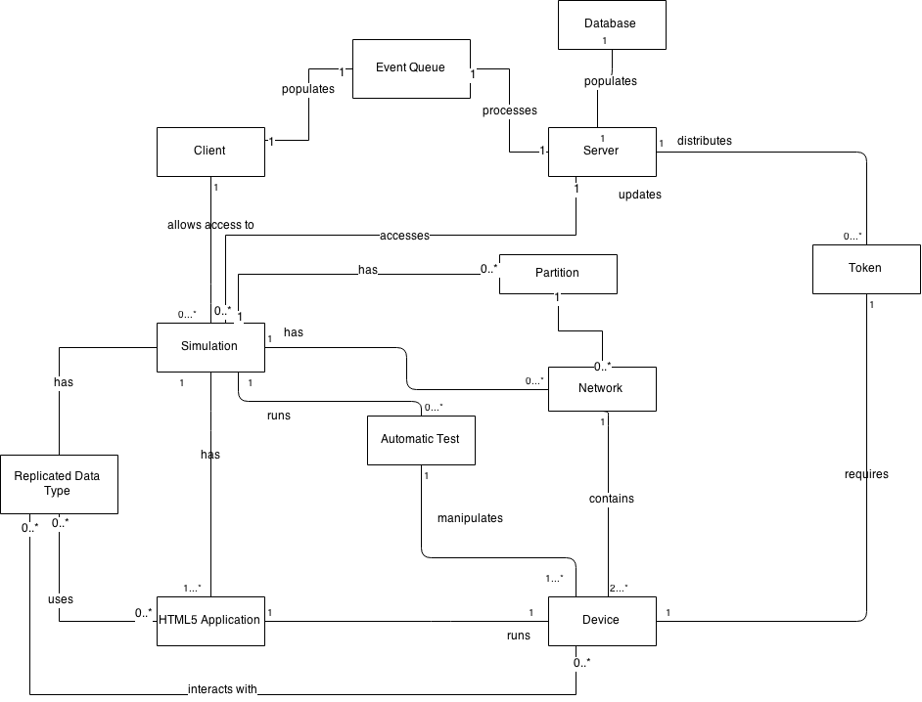
Domain Model Design Decisions
We designed the domain model in order to give us a concrete overview of the conceptual classes which we will be using for our system. This allows us to construct a solid foundation for our project, and plan for the organization of our system before anything is implemented. We believe that the above conceptual classes was the most logical separation of our system. The concepts of all of the above classes were implemented this iteration in our software.

